OUTPUT
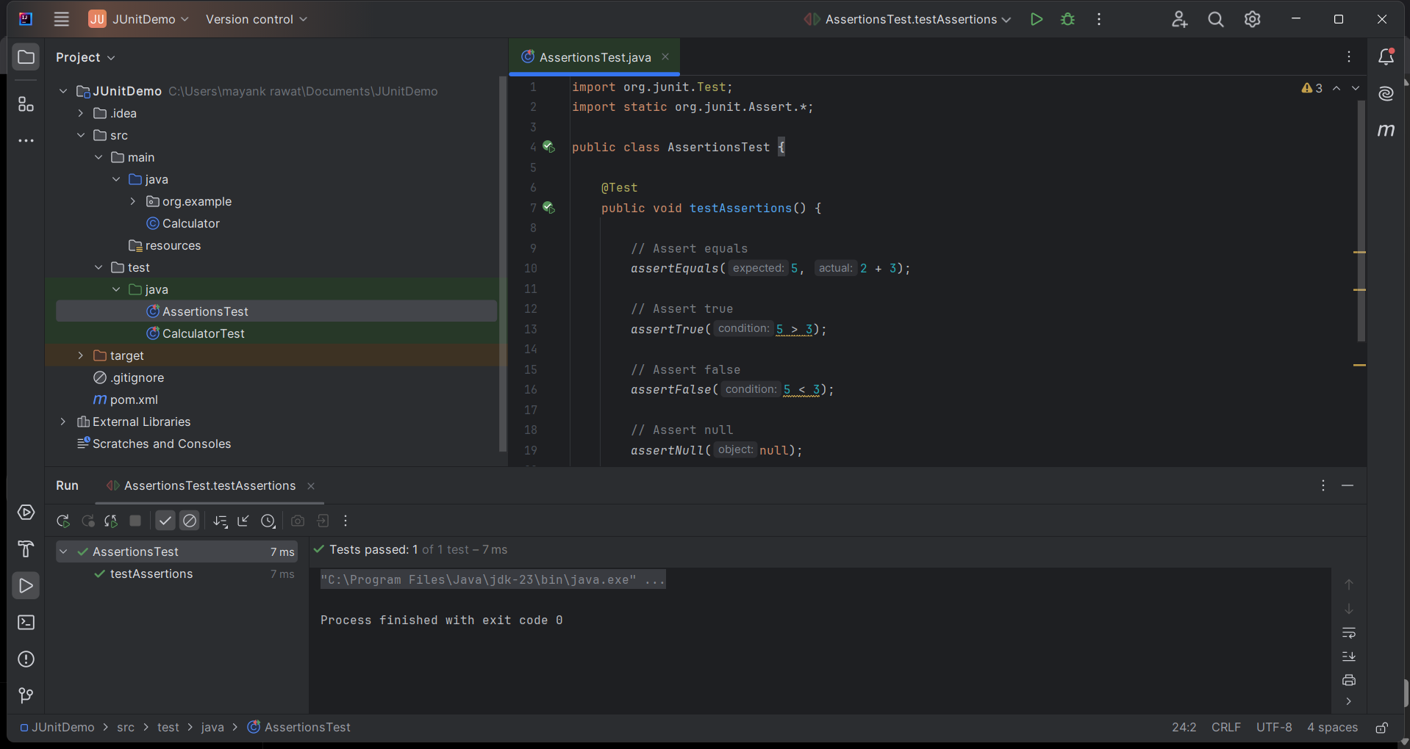

CODE

AssertionsTest
import org.junit.Test;
import static org.junit.Assert.*;

public class AssertionsTest {

@Test
public void testAssertions() {

// Assert equals
assertEquals(5, 2 + 3);

// Assert true
assertTrue(5 > 3);

// Assert false
assertFalse(5 < 3);

// Assert null
assertNull(null);

// Assert not null
assertNotNull(new Object());
}
}

